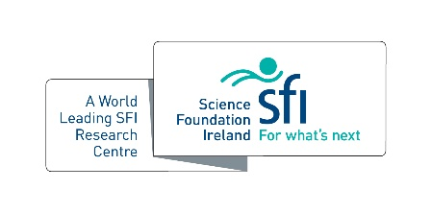
SSPC Academic Collaboration of the Year

In recognition of collaborative projects between academics at different institutions
within SSPC that have yielded outputs that would not have been possible without the involvement of both/more.
Criteria
- Core funded SSPC activity
- Lead applicant SSPC member
- Minimum of 2 co-applicants
- Must include evidence for extent and impact of the collaboration in 2021

Name(s):

Host Institution(s):

Please outline the clear development of the collaboration demonstrating relationships, for example, joint publications, significant team mobility, co-funded projects (1,000 words max.)

