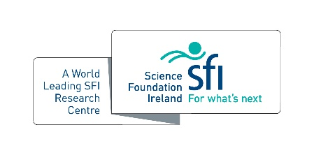
SSPC Commercial Activity of Year Award

This award recognises the outstanding contribution of knowledge exchange, knowledge transfer and/or commercialisation activities for an individual or a group. This is taking into account activity at any stage of the commercialisation pipeline.

Criteria
- SSPC centre member – PhD/PDRA/Investigator and respective project partners
- Projects can span all stages of research commercialisation, industry engagement and entrepreneurship
- The award recognises great work, so please be encouraged to put forth projects which
demonstrate originality, creative business insight, and/or deliver significant societal impact

Name(s):

Host Institution(s):

Partner(s):

Please describe the project? (300 words max.)

Please provide evidence of how an essential contribution was made to enable the outcomes. (250 words max.)

How you expect your solution to be commercialised? Please list and detail any related invention disclosures, licences granted, patent applications filed or granted, or Commercialisation Awards, for example, Innovation Partnership Programme or Commercialisation Fund or other or spin-out? (250 words max.)

