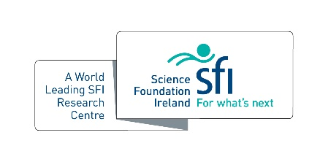
SSPC EDI Award

This award recognises an individual, group or organisation that has demonstrated exceptional commitment to the promotion or advancement of Equality, Diversity and Inclusion (EDI).
Please see SSPC’s Equality, Diversity and Inclusion Charter here

Criteria
- SSPC centre member – PhD/PDRA/Investigator/industry or academic partner

Evaluation Criteria
The winning individual may have contributed to positive change in the sector in any of the following ways:

- Adopting a strategic approach to embedding a commitment to EDI in all areas of operation
- Taken action to ensure a workforce profile that is representative of its client base and the community that it serves
- Taken positive steps to train and develop diverse talent (including ex-service personnel and/or ex-offenders). Addressing identified under-representation in senior roles in a sustainable manner
- Acted as a senior role model, sponsor or ally in championing EDI in the professional workplace
- Taken specific actions (e.g., addressing inappropriate language and/or harassment) to improve the workplace culture
- Demonstrated a high-level of employee engagement to identify sustainable approaches to embedding EDI
- Acted as a visible role model providing inspiration to members of an under-represented groups both within and beyond their organisation

Name:

Host Institution:

Nominator(s):

Please outline the impact of advancing and championing EDI through the evaluation criteria outlined above (500 words max.)

