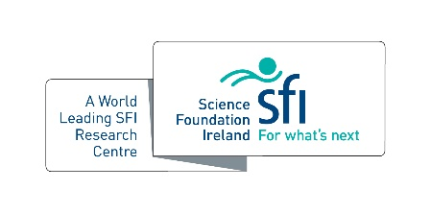
SSPC Education & Public Engagement Champion of the Year

For any member of the SSPC Community (PhD, PDRA, Investigators) who has demonstrated commitment to and flair for public engagement and outreach in 2021.

Name:

Host Institution:

The benefits of taking part in SSPC’s public engagement activities are………… (500 words max)

List of EPE activities undertaken in 2020

