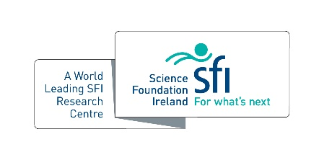
SSPC Graduate of the Year

For exceptional PhD graduates based on their PhD achievements and outputs:
Criteria
- PhD viva-defence completed in 2021 calendar year
- SSPC core-funded students
- Endorsed by PhD Supervisor

Name:

PhD Title:

Supervisor:

Host Institution:

PhD Project Description (500 words max)

How did SSPC contribute to my PhD experience (500 words max)

Top 3 Outputs from PhD Project
