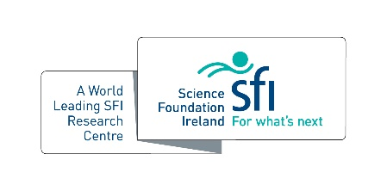
SSPC Industrial PhD Placement Award

For exceptional and impactful SSPC PhD placement experiences
Criteria
- Industrial PhD placement completed through SSPC with an SSPC partner company in 2021
- SSPC core-funded students/formal associates (attributed as SSPC team members on sesame)
- Endorsed by industry nominator indicated on form

Name:

PhD Title:

Supervisor:

Host Institution:

PhD Placement Description (500 words max)

Explain the impact of the placement (500 words max)

