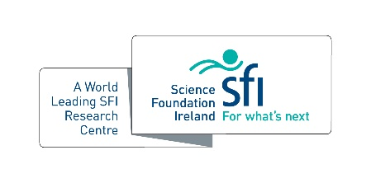
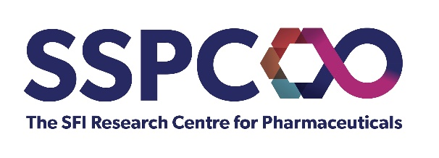
SSPC Industry Impact of the Year

For research outputs that have made a tangible impact with/for an industrial partner

Criteria
- SSPC centre member – PhD/PDRA/Investigator
- Impact realized in 2021
- Independent endorsement from industry partner

Name(s):

Host Institution(s):

Partner(s):

Please outline the impact of the partnership/how industry has informed the research being conducted (500 words max.)

Please outline the benefits of this collaboration to both parties (500 words max.)

