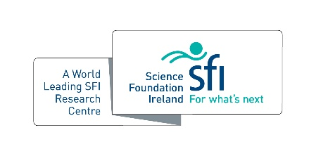
SSPC Mentorship Award

This award recognises outstanding mentorship provided by an SSPC researcher,
based on the experiences of the nominee's formal and informal mentees
and not personal career achievements

Criteria
- SSPC centre member – Principal and Funded Investigator
- Nominators must be a previous or current mentee(s) of the mentor
- Self-nominations will not be accepted

Evaluation Criteria
To be eligible for nomination a mentor should have:

- Demonstrated a commitment to nurturing the intellectual, creative, scholarly and / or professional growth of their mentees
- Enabled their mentees to become independent and be recognised in their own right as a subject matter expert
- Shown a sustained commitment to a mentoring relationship that has supported the career progression and / or the personal development of mentees.

Name:

Host Institution:

Nominator(s):

Please outline the impact of mentorship through the evaluation criteria outlined above (500 words max.)

